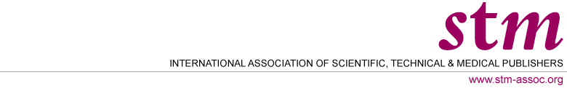

STM Membership Application – 2015

The following organisation would like to apply for membership in the International Association of Scientific, Technical & Medical Publishers (STM)

Organisation
Address
Name Representative
Telephone
E-mail
Fax
Website
2014 Revenue*
What are your reasons for joining STM?
Main location/
address
Subsidiaries/
addresses
Principals of company

Mission Statement
History of organization
Product Offerings
Commercial or not-for-profit

*Fees based on revenue

Regular membership fees are based on all revenues from primary or secondary/database or tertiary publishing (books and journals) in the fields of pure and applied science, technology, medicine, social and behavioural sciences and humanities: that is, all academic and professional/reference level publishing.

Associate member fees are based on the organisation’s global revenues.

Respond in confidence
- Application form to be returned E-mail: beadle@stm-assoc.org Fax+44 1865 339325

- Review of the application will take approximately 10 business days from acknowledgement of application.

