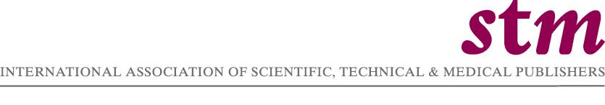

International Association of Scientific, Technical & Medical Publishers

Oxford Brookes University

STM Master Class

‘Developing Strategic Business Skills’

Pembroke College, University of Oxford
Monday 18th – Thursday 21st September 2006

Course Director: Richard Balkwill

Associate Consultant in Publishing Studies, Oxford Brookes University

Programme

Monday 18 September

12.00 Registration

12.30 Lunch

13.45 Keynote introduction
Michael Mabe, Chief Executive, STM Association
Richard Balkwill, Course Director

14.00 ‘Navigating the turbulence of change’
Martin Tanke, Managing Director, Journal Publishing, Elsevier S & T

15.00 Break

15.15 Course quiz: ‘So you think you know about STM Publishing?’

15.45 Introduction to case study
‘What are the biggest threats to my company?’

16.00 Group work on case study

16.30 Break

16.45 Groups feed back their findings

17.15 Poker School
Led by Chris Blake, Chairman, Earthscan

18.00 Break

18.30 Master Class photograph

19.15 Dinner and keynote speech in Hall
Guest speaker: Dr Evan Harris, Liberal Democrat Member of
UK Parliament

Tuesday 19 September

09.00 ‘Risk analysis and investment strategies’
Chris Blake, Chairman, Earthscan

10.45 Break

11.15 ‘A strategic look at publishing: an outsider’s view’
Christopher Wheaton, European Media Analyst, RCM
(Allianz Global Investors)

12.15 Introduction to case study
‘Acquisition strategies and investment opportunities’

13.00 Lunch

14.00 Group work on case study

14.45 Groups feed back their responses to the case study

15.30 Break

16.00 ‘Managing merged businesses’
Jim McGinty, Vice Chairman, Cambridge Information Group

17.00 Close

Evening free: delegates are free to visit Oxford and make their own dinner arrangements.

Wednesday 20 September

09.00 ‘Managing the digital rights environment’
Dr Alicia Wise, Chief Executive, Publishers Licensing Society
Sue Joshua, Director of Legal Affairs, John Wiley & Son

10.30 Break

10.50 ‘Succeeding in a turbulent environment: a living strategy’
Dawn Bova, Director of Human Resources, Blackwell Publishing
Gareth Williams, Human Resources Director, Taylor & Francis Group

12.30 Introduction to group work and debate
‘Strategic issues facing STM publishers’

13.00 Lunch

14.00 ‘Structuring and managing global businesses’
Dr Pieter Bolman, former Chief Executive, STM Association
Einar Fredriksson, Director, I0S Press

15.30 Groups work on issues for debate

17.30 Break

18.15 Coach leaves for Headington Hill Hall, Oxford Brookes University

  - Visit and Reception: Oxford Centre for International Publishing
Studies, School of Arts and Humanities, at the Richard Hamilton
Building, Heading Hill Hall campus.

  - Delegates move down to Headington Hill Hall to meeting the
evening’s guests

19.30 Dinner sponsored by Elsevier

Guest speakers: Sir Muir Gray, Director of Clinical Knowledge,
Process and Safety for the National Health Service
Professor Linda Fitzsimmons, Dean of the School of Arts and Humanities, Oxford Brookes University

22.00 Coach returns to Pembroke College

Thursday 21 September

09.00 ‘Creating a new vision for an enterprise’
Hugh Look, Senior Consultant, Rightscom

10.30 Break

10.45 ‘Strategic issues facing STM publishers’
Debate and discussion

12.15 Comments and feedback on final group work

12.30 Presentation of certificates
Course summary

13.00 Optional lunch

14.00 Course closes

