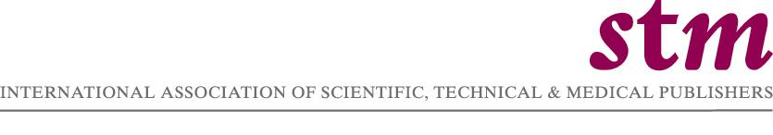

September 12, 2006

39th Annual General Meeting
of the
International Association of Scientific, Technical
and Medical Publishers

2 October 2006
5:15 – 6:15
Arabella Sheraton Grand Hotel Frankfurt, Frankfurt Germany

Agenda

- Welcome from the Chair
- Approval of Minutes of the 38th Annual General Meeting
- Financial statement 2005
- Results of the STM Board elections 2006 and Officers of the Association for 2006
- Any Other Business
- Adjournment

