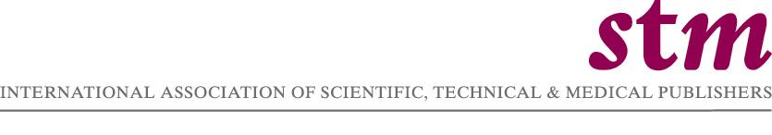

Contact: Michael Mabe (STM) Berndt Dugall (subito e.V.)
Email: linda@stm.nl Email: braun@subito-doc.de

FOR IMMEDIATE RELEASE

SUBITO AND STM PUBLISHERS REACH AGREEMENT ON INTERNATIONAL DOCUMENT DELIVERY
London, England, 20 July 2006 – The International Association of Scientific, Technical & Medical Publishers (STM), a trade association, and subito e.V., a non-profit registered association of libraries from Germany, Austria and Switzerland, announced today that subito e.V. and 21 leading publishers have recently concluded an agreement to provide an international document delivery service of copied articles. STM publishers and subito e.V. are satisfied that the found license agreement enables them to bridge their different interpretation as to which extent the applicable copyright law allows international document delivery service.
The parties emphasise that the concluded license agreement furthers their shared commitment to increase visibility and access to scientific and medical information for the benefit of research and education. The following publishers have signed the agreement with subito e.V.:
Acoustical Society of America, Akademie Verlag, American Association of Physicists in Medicine, American Association of Physics Teachers, American Astronomical Society, American Chemical Society, American Geophysical Union, American Institute of Physics, American Physical Society, American Vacuum Society (AVS-The Science and Technology Society), Blackwell Publishing, Elsevier, Institute of Physics Publishing, John Wiley & Sons, Mohr Siebeck, Sellier, European Law Publishers, Oldenbourg Wissenschaftsverlag, Optical Society of America, The Society of Rheology, Vittoria Klostermann, Walter de Gruyter.
"The agreements reached by our members represent months of discussions in which all parties attempted to understand the views of all involved. The educational and research communities, especially within Europe, are the beneficiaries of these agreements, by which a significant percentage of international science journal information will be made available to the user communities through the subito supply services. We are very pleased for our members to have concluded these agreements." said Michael Mabe, CEO of STM.
While each agreement is entered into by subito e.V. and the respective publisher, it also has effect on third parties – all member libraries of subito e.V. are benefiting from the license granted. subito e.V. and its member libraries are entitled to reproduce and transmit articles by mail, fax and DRM-protected Internet download.
Within the coming weeks, subito e.V. will put the reached agreement into practice by re-launching its international services on www.subito-doc.de. In concrete, the agreement covers two types of cross border delivery. First, the "Subito Direct Customer Service – International (SDS)", which provides document delivery direct to end users' desktops. Second, the "Subito Library Service – International (SLS)", which enables institutional libraries to make documents available to their patrons.
For "Subito Direct Customer Service – International (SDS)", the agreement includes the entire world with the exception of Germany, Switzerland, Liechtenstein, and Austria. "Subito Library Service – International (SLS)" covers Europe as widely defined (except German-speaking areas) and Russia.
"The agreements provide subito e.V. with an adequate certainty in terms of copyright law allowing subito e.V. to offer its document delivery services on an international level. The alternative of obtaining an adequate state of legal certainty by reviewing each individual jurisdiction subito e.V. is delivering copies to was considered unreasonable in time and effort. We look forward to a prosperous and successful cooperation with the STM publishers and hold the strong aspiration that in the near future a substantial number of agreements can be concluded. Science and education shall benefit substantially from our cooperation." said Berndt Dugall, Chairman of subito e.V. and director of the library of the Wolfgang von Goethe University Frankfurt am Main.

The International Association of Scientific, Technical & Medical Publishers(STM) is a global trade association with approximately 100 member publishing organisations, both large and small, and for-profit and not-for profit, collectively responsible for about 60% of the global output of research articles each year. STM’s mission is assisting publishers and their authors with their activities by disseminating results of STM research, assisting national and international organisations and industries to improve electronic dissemination of STM information, and working with international and national publishers associations and other governmental and professional bodies, concerned with these tasks.

