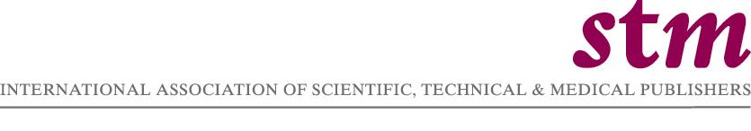

Contact: Pieter Bolman
e-mail: linda@stm.nl

For Immediate Release

document Deliverer actamed held liable for copyright infringement and declares bankruptcy

London, England, March 27, 2006 – In 2005, scientific, technical, and medical (STM) publishers brought a series of legal actions for massive copyright infringement against Via Marketing & Promotions SA, also known as ActaMed, a document delivery service primarily for pharmaceutical companies.

In February 2006, the U.S. District Court for the District of Massachusetts ruled that both ActaMed and its former President and General Director, Mr. Robert Gmelig Meyling, were liable for infringing U.S. copyright law with “willful disregard.” The court ordered ActaMed to pay statutory damages of $200,000 to the U.S. publishers who had brought the case (see below). The court also ordered that the defendants, and the employees of ActaMed, are permanently forbidden to further distribute, or import into the U.S., any kind of print, electronic or other reproductions of the content of the publishers’ journals, books, and other publications without their permission. The full judgment can be accessed at : http://www.kcslegal.com/ActaMedJudgment.pdf.

A second civil suit was brought in Lugano, Switzerland by the European publishers (see below). This suit currently is on hold, due to the fact that, in January 2006, the bankruptcy court in Lugano, Switzerland, declared ActaMed bankrupt, partly as a result of the substantial damages claimed by publishers. The official notice of commencement of the bankruptcy proceedings can be accessed at: https://www.shab.ch/DOWNLOADPART/N3033718/N2006.03212108.pdf
ActaMed does no longer offer its services, its website was shut down in January 2006.

In addition to civil proceedings, the public prosecutor in Lugano, Switzerland initiated a preliminary investigation including against Mr. Robert Gmelig Meyling. The investigation is still pending. As part of the investigation, the prosecutor’s office
sequestered ActaMed’s database which contained (without permission) some 475,000 digitized full-text articles in various languages from 7,000 major international medical journals, including those published by the publishers who brought the legal action.
ActaMed used this database to distribute electronic and printed copies and reprints to its clients.

“This action closes down an unscrupulous copyright infringement operation that took place on a grand scale”, said Joseph Appel, Publishing Counsel, Massachusetts Medical Society (U.S.A). “The number of illegally copied articles was truly staggering. They represent a significant financial injury to the copyright holders.”

“The publishers believe that stopping ActaMed’s piracy was critical to protecting the interests of the majority of international document delivery services, who do comply with copyright law”, said Karen Gibson, Associate Director Rights, Blackwell Publishing Ltd. (U.K.).

The plaintiffs in the Swiss civil action are Elsevier B.V. (Netherlands), Blackwell Publishing Ltd. (U.K.), Springer Verlag GmbH (Germany), BMJ Publishing Group Ltd. (U.K.), Adis International Ltd. (U.K.) and Birkhäuser Verlag AG (Switzerland).

The plaintiffs in the Massachusetts action are Blackwell Publishing Inc., Elsevier Inc., Massachusetts Medical Society, and Wiley-Liss Inc.

The International Association of STM Publishers (STM) has offices in The Hague and London. STM is a broad organisation, which includes large and small companies, not for profit organisations and learned societies, traditional primary and secondary publishers and new players. The mission of STM is to support the goals of its members by representing and advocating their best interests around the globe. www.stm-assoc.org

# # # #

