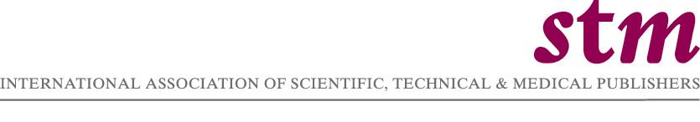

NEWS RELEASE

Contact: Linda Young linda@stm.nl
Tel: +44 20 7164 2022

For immediate release

Michael A. Mabe Appointed CEO of International Association of Scientific, Technical & Medical Publishers

London, England, 8 March, 2006 – The International Association of Scientific, Technical & Medical Publishers (STM) a global membership organisation representing more than 100 member companies in copyright issues, technology developments, and end user relations, announced today the appointment of Michael A. Mabe as its Chief Executive Officer.

Effective May 2, 2006, Mabe will replace Dr. Pieter S. H. Bolman, who is stepping down after a two year post as CEO. Mabe stated, ‘I am delighted and honoured to be appointed as CEO of the International Association of STM Publishers. It is daunting to follow on from such an eminent predecessor as Dr. Pieter Bolman. Pieter has contributed enormously to the development of the organisation, and its important international lobbying role. I very much hope to build on his excellent beginnings.’

Jerry Cowhig, Managing Director of Institute of Physics Publishing and current Chair of STM, said: ‘I am delighted to welcome Michael Mabe as our CEO and I look forward to working closely with him. His high reputation in publishing together with his knowledge and experience will be invaluable to the Association and its members.

I would like to add my appreciation to Pieter Bolman, who created the new role of CEO, for all he has contributed to the Association and to STM publishing during his distinguished career.’

According to Mabe, ‘STM publishers are facing a wider range of challenges in a more rapidly changing market than ever before: calls for public access to publicly funded research, the continuing revolution of the digital transition, challenges to

- More -

copyright, the need to articulate publisher value-added to broader constituencies than in the past. In all these areas STM must make a real difference for its members and for the wider publishing community. I look forward to working with the STM Board, its staff and members to strengthen our ability to respond and proactively to make the case for publishers and publishing.’

From 1999 until the present, Mabe has been Director of Academic Relations for Elsevier where he was international academic affairs spokesperson responsible for Elsevier’s relations and strategy with the international research community, science funding bodies and governmental agencies. Mabe was also responsible for the direction of research and relationship programmes, and a member of Elsevier’s copyright committee. Prior to that position, Mabe was Publishing Director of Elsevier’s global materials science program.

Mabe also worked at Pergamon Press, Ltd as both Editorial Director and Senior Publishing Editor in Materials Science and Editorial Manager in the Scientific Encyclopaedia Department. Mabe has also held senior positions at the British Standards Institution and Oxford University Press.

Mabe graduated as Bachelor of Arts with Honours in Chemistry and as Master of Arts from St Catherine’s College, Oxford University. Mabe also serves as a Director of the Management Committee for the Centre for Publishing Studies, University College, London. Mabe is also a Visiting Professor in Information Science at City University and the University of Tennessee.

_ _ _ _ _ _ _ _

The International Association of STM Publishers (STM) has offices in The Hague and London. STM is a broad organisation, which includes large and small companies, not for profit organisations and learned societies, traditional primary and secondary publishers and new players. The mission of STM is to support the goals of its members by representing and advocating their best interests around the globe. www.stm-assoc.org

- End -

